EXPERIMENT 07

Consider Sales Data set.
Launch the power BI Desktop. Load the data set sales to the power BI Desktop. If our data contains any null values, we can transform the data else load it to the canvas.
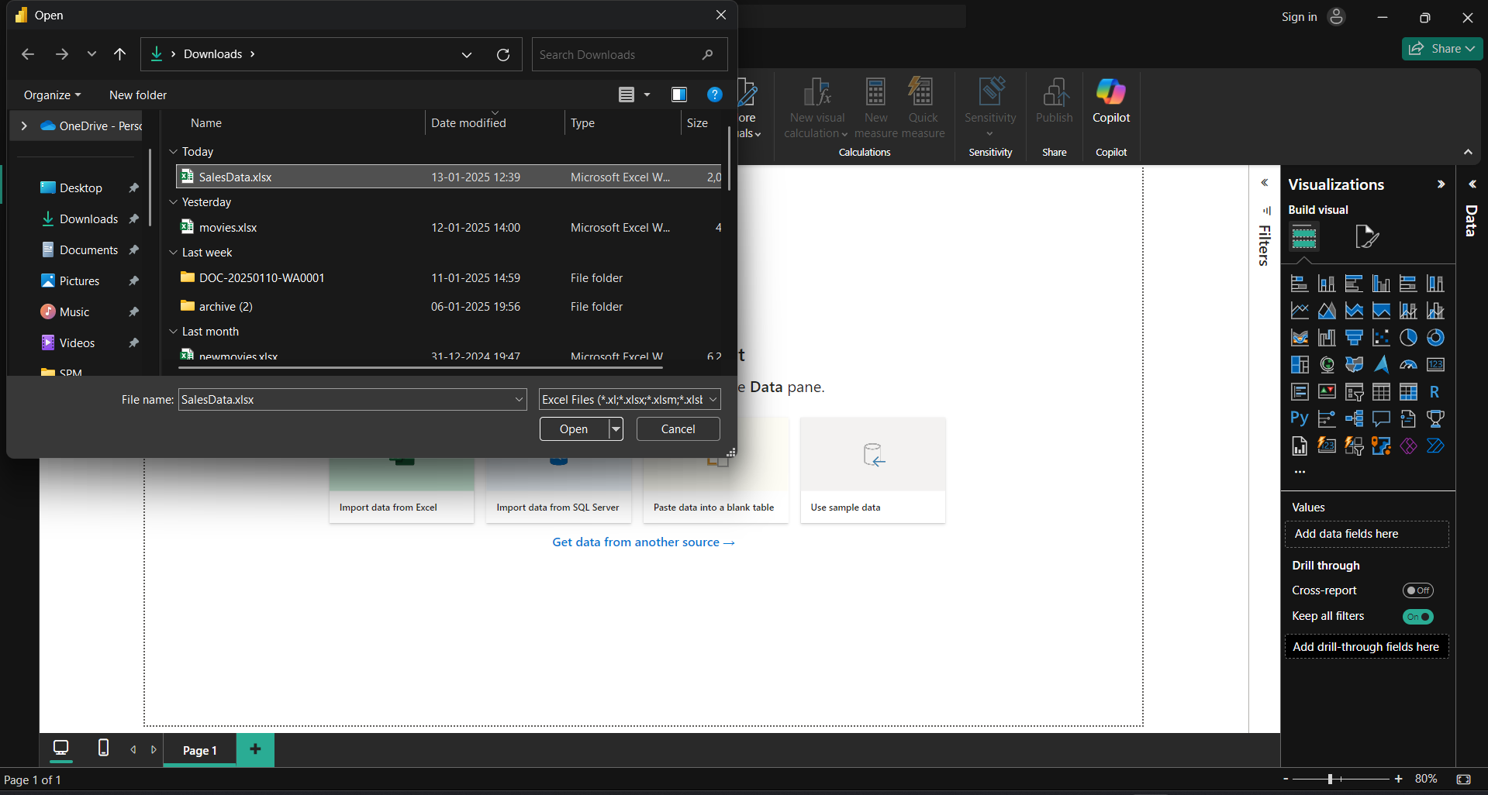
- Create Tables with Specific Calculations
- Manufacturing, sum of sales, columns.
Go to the Report view. Select the Table visualization. Drag Manufacturer from the Fields pane to the Rows area. Drag Sales to the Values area, and ensure the aggregation is set to Sum
.

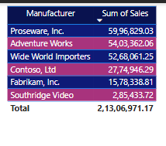

- Product Category, sum of profits etc
Create another Table visualization. Drag Product Category to the Rows area. Drag Profit to the Values area, ensuring it is set to Sum.
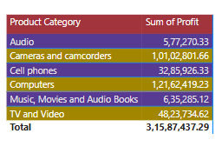

- Find Answers for the following:
- Which Manufacturer has the highest Sales?
Use the "Sales by Manufacturer" table. Sort the table by the Sales column in descending order. The manufacturer at the top of the list has the highest sales.

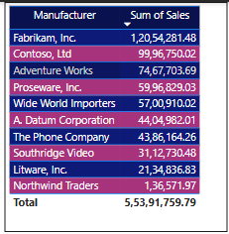

- Which Product Category has the lowest Profit value?
Use the "Profit by Product Category" table. Sort the table by the Profit column in ascending order. The product category at the top has the lowest profit.

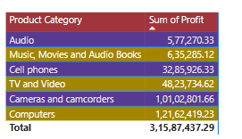

- Which Channel has the highest Cost of Sales?
Create a Table visualization. Drag Channel to the Rows area. Drag Cost of Sales to the Values area, ensuring it is summed. Sort by Cost of Sales in descending order to find the channel with the highest cost.

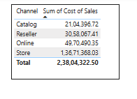

- Which Manufacturer has the highest Profit?
Create a Table with Manufacturer in the Rows area. Drag Profit to the Values area and ensure it is summed. Sort by Profit in descending order to find the top manufacturer.

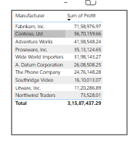

- Which Promotion Name has the highest Sales?
Create a Table visualization. Drag Promotion Name to the Rows area. Drag Sales to the Values area. Sort the table by Sales in descending order to find the top promotion.

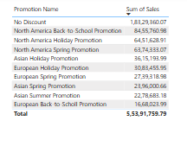

- Which Product Sub Category has the highest Profit?
Create a Table visualization. Drag Product Sub Category to the Rows area. Drag Profit to the Values area. Sort by Profit in descending order.

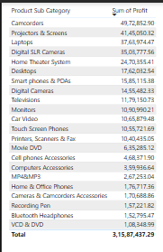
- Perform cross filtering between tables
Ensure relationships between tables are set correctly in the Model view. Use filters to enable cross-filtering across different tables.

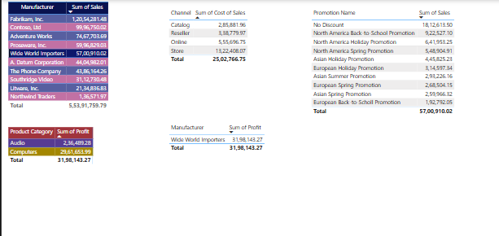

- Create matrix visualization for product category, Region, sum of sales
Select the Matrix visualization. Drag Product Category to the Rows area. Drag Region to the Columns area. Drag Sales to the Values area, ensuring it is summed. The matrix will display sales summarized by product category and region.

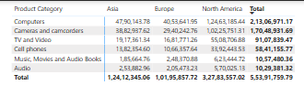

- Create a card visualization for total sales, Total Profits, Avg Profits, Highest Profits, Lower Profits etc. and apply formatting
- Create a Card visualization. Drag Sales to the Values area, and set the aggregation to Sum.
- Create another Card and drag Profit to the Values area, set to Sum.
- Create a calculated measure:
Avg_Profit = AVERAGE('Dataset'[Profit])
Use this measure in a Card visualization.
- Create a calculated measure:
Max_Profit = MAX('Dataset'[Profit])
Use in a Card visualization.
- Create a calculated measure:
Min_Profit = MIN('Dataset'[Profit])
Use in a Card visualization.

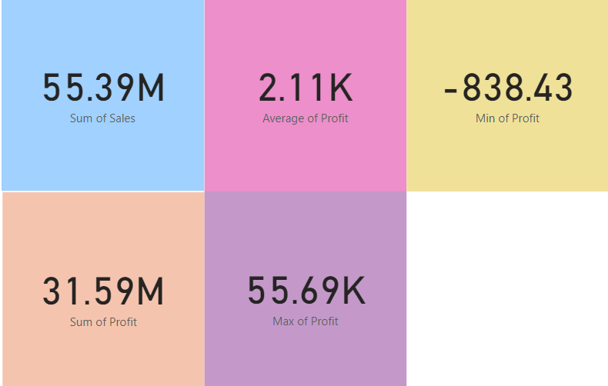

- Apply appropriate visualization. Create calculations for Visualization
- Calculate the difference between sum of Sales and Sum of Profits.

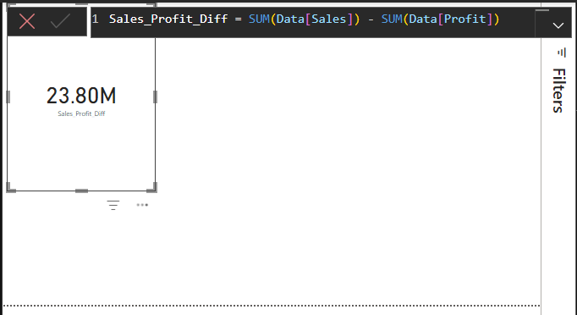

- Calculate Profit Ratio. (Hint: Sum of Profit/Sum of Sales). Also demonstrate using in built function, e.g., DIVIDE
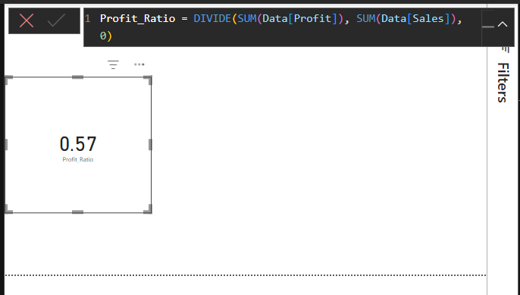

- Calculate the average sales per product for each of manufacturers. (Hint: Sum of sales/Count of Product Name)

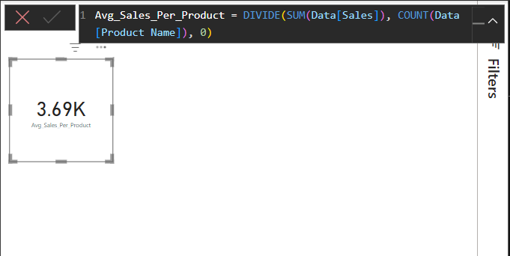

- Calculate the Total for category region using in-built function
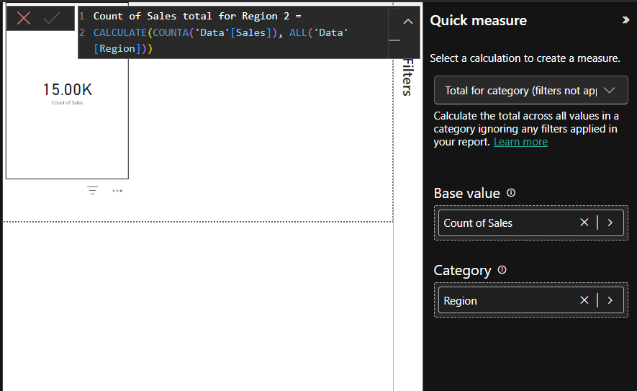

- Apply Filters and Slicers
Add Slicers for Region, Product Category, and Channel. Set interactions between slicers and visualizations to enable dynamic filtering.
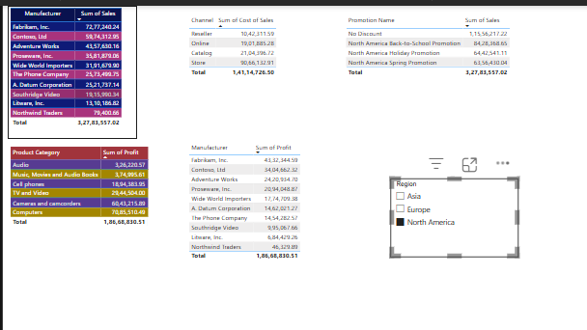
- Build Graphs. Draw Trend Analysis Graph. Show trends and forecasting
Sales by Year and Quarter: Use an Area Chart. Drag Order Date to the Axis area, set to hierarchy (Year, Quarter). Drag Sales to the Values area.

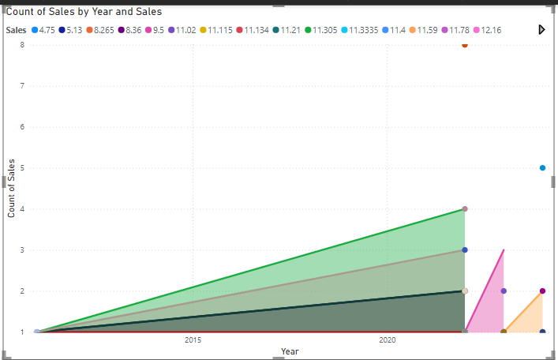

Profit by Product Category: Use a Column Chart. Drag Product Category to the Axis area. Drag Profit to the Values area.

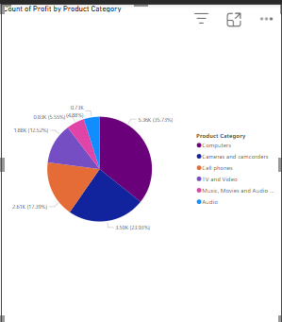
- Create Interactive Dashboard
- Create an Interactive Report
- Create a heading Sales Report
- Create the following Card visualizations: Total Sales, Total Profit, Average Sales, Number of Products, Create a Area graph displaying Sales by Year and Quarter, Create a Column graph displaying Profit by Product Category
